Warwickshire County Council

Job title: | Service Manager – County Highways
Directorate: | Communities
Accountable to: | Assistant Director of Environment Services
Salary grade | Hay T3B £68,684 - £75,911

Part A - Generic job purpose and capabilities
You will play an active role as part of our senior leadership team working in partnership with our Strategy and Commissioning Managers to innovate our service delivery capabilities. You will support the Assistant Director and Service Managers in achieving Warwickshire County Council’s (WCC’s) vision and outcomes through integrated planning and flexible use of resources. Report on delivery of outcomes to stakeholders including elected members and other council officers.

You will have direct operational responsibility for County Highways ensuring that services are delivered proportionate to need, building and strengthening our community capacity to enable a stronger resilience base. You will maximise commercial opportunities and income streams to enable the financial stability of WCC. You will develop and maintain good working relationships with our range of partners including the voluntary sector.
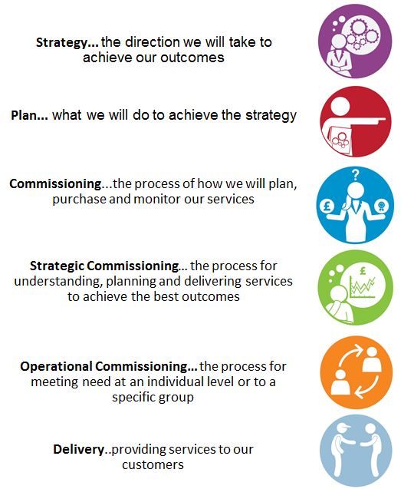

Generic competencies for Service Manager
Generic Capability | Descriptor
Business Acumen | - Define the medium term (1-3 years) delivery objectives and plans  - Manage costs down  - Deliver savings plans  - Deliver on income targets

- Contribute to the strategic operational longer term vision of the service.
- Define the delivery plans (1-3 years) and align with strategic objectives and outcomes.
- Deliver the income targets specified (1-3 years).
- Deliver the 1-3 year savings targets allocated to the service.
- Contribute to policy and procedure development to maximise effectiveness and efficiencies.

Generic Capability | Descriptor
Performance & standards | - Statutory compliance  - Professional practice  - Procedure compliance  - Dealing with performance

- Ensure statutory or regulatory duties are in place and delivered across the service.
- Ensure the safe operation of the business and compliance with appropriate regulations and legislation.
- Ensuring the service meets any contractual targets and performance measures.
- Contribute to the overall delivery framework for contract and quality management.
- Set and maintain the right policies, procedures and effective and efficient processes to achieve the service objectives.

Generic Capability | Descriptor
Operational leadership | - Contract and supplier management  - Deliver operational excellence through others  - Workforce demand forecasting and planning  - Focus on operational continuous improvement  - Focus on the voice of the customer  - Managing operational complexity

- Ensure the service delivers against its key business objectives.
- Set and review operational budgets to manage costs down.
- Ensure effective quality assurance, performance management and use of data and quality to maximise performance of the service.
- Build and maintain effective relationships with key stakeholder groups eg Senior Leadership, Strategy and Commissioning Managers, Service Managers, Members, Partners and Commercial providers.
- Responsible for the workforce capacity and continuity planning.
- Drive operational improvement across the team managers to improve service outcomes.
- Ensure that customer pathways are working to their optimum efficiency.
- Ensure the voice of the customer is embedded in any service improvement plans.
- Lead on the service redesign transformation plans in line with WCC’s new operating model.
- Research new technologies and alternative delivery methods to maximise efficiency.
- Maintain and/or improve customer experience scores.
- Ability to identify staff development and training needs.
- Provide guidance, training, development and support to team managers.
- Lead and support teams through organisational change.
Generic leadership competencies

Capability | Descriptor
People leadership | - Drives and motivates to maintain high performance  - Deals with performance issues

- Enable a high performance culture where innovation and creativity is encouraged and rewarded.
- Address performance issues within the service.
- Identify and develop the required capabilities of the team through effective talent management planning.

Capability | Descriptor
Management of resources & planning | - Effective budget management  - Monitors quality performance framework  - Works across organisational boundaries  - Effective service design

- Effective management of service budget and associated savings.
- Develop and manage a highly effective delivery team/function.
- Identify the capacity of the delivery team through effective workforce planning.
- Contribute to the WCC’s 1-3 year medium term financial plan, including income targets where applicable.
- Manage the quality assurance framework for the service/business unit.
- Develop and implement integrated working across services of WCC.

Capability | Descriptor
Organisational leadership & resilience | - Implements organisational wide change  - Role model of modern working principles  - Focus on continuous improvement

- Communicate a clear vision of strategy and commissioning and its objectives to enable key stakeholders to understand and contribute to the context and direction of the service.
- Provide visible leadership and support teams through organisational change.
- Role model of modern ways of working.
- Act and operate corporately across WCC adopting a one council approach.
- Act as a positive role model for WCC’s values and behaviours at all times.
- Represent the interests of the Council on external bodies and networks.
- Maintaining business continuity in the event of service disruption.

Part B - Portfolio requirements

Delivery responsibilities

Statutory responsibilities (if applicable)
Specific experience | Experience of leading and managing a team of staff.  Coordinating and delivering successful outcomes with partners.  Experience of managing in a political environment.  Budget management.
Specific qualifications/and registration | Not applicable
Budget responsibility | £9.9m annual budget
FTE responsibility (line management) | 127.0 FTE
Key stakeholder relationships | Key partner relationship management

WCC values and behaviours
The post holder must be able to demonstrate that they role model the WCC values and behaviours.
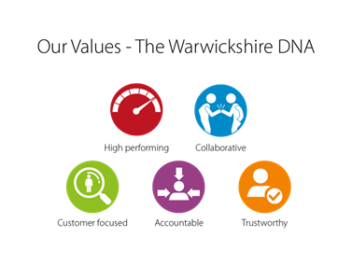
Our Behaviours

